

QPS - Intune MDM and MAM implementation
22 August 2025

Contents
Document Control 3
Project Information 3
Responsibilities 3
1. Overview 4
1.1 Overview 4
1.2 Business Requirements 4
2. Policy Matrix 5
2.1 Intune MAM Policies 5
2.2 Intune MDM Policies 9
2.3 Conditional Access Policies 9
2.4 Microsoft Defender Cloud App Policies 10

Document Control

Project Information
Project Name | 3596263 - QPS - Intune MDM and MAM
Program Manager | George Alex

Responsibilities
Authors | Role | Contact Details
Olli Ojala | Cloud Project Engineer | E: olli.ojala@orro.group

Version | Date | Amendment | Author
0.1 | 22/08/2025 | First Draft | Olli Ojala
1.0 | 30/09/2025 | First release | Olli Ojala

- Overview
  - Overview
This document presents the detailed design for the Mobile Device Management (MDM) and Mobile Application Management (MAM) solution to be implemented for Queensland Police Service (QPS) corporate-owned and Bring Your Own Device (BYOD) endpoints. The objective of this solution is to enable secure, compliant, and seamless access to corporate resources from both personal and QPS-managed mobile devices, while maintaining strict data protection controls and minimizing risk to the enterprise environment.
The solution is designed to:
- Ensure corporate data remains secure and compliant when accessed from mobile devices.
- Support a hybrid device environment that includes both QPS-owned iOS and Android devices as well as employee-owned devices (iOS, Android, Windows and MacOS.
- Enforce consistent security controls and access requirements through modern management and Zero Trust principles.
- Balance user experience with organizational security needs by applying differentiated policies to corporate and personal devices.
To achieve this, the solution leverages Microsoft Endpoint Manager (Intune) in combination with Microsoft Entra ID Conditional Access and Microsoft Defender for Cloud Apps. Key components include:
- Conditional Access Policies – Enforce adaptive, context-based access controls based on user, device compliance, application sensitivity, and risk signals. These policies are applied at the time of authentication and authorization whenever a user attempts to access corporate resources (e.g., Microsoft 365, SaaS apps, or on-premises apps published through Entra ID). The evaluation occurs in real time, ensuring access is only granted if the defined conditions (such as device health, location, risk level, or MFA requirements) are satisfied.
- Intune MAM Policies – Protect corporate data at the application level on BYOD devices without requiring full device enrollment. These policies are applied when a user accesses or uses corporate applications and data (e.g., Outlook, Teams, OneDrive) on their personal device. The controls are enforced in real time during application launch, data access, and data transfer actions (such as copy, paste, save, or share), ensuring corporate information remains protected without impacting personal apps or data on the device. A selective wipe is triggered when corporate access is revoked — for example, if the user leaves the organization or their account is disabled. In such cases, only corporate data and app access are removed, while personal data on the device remains untouched.
- Intune MDM Policies – Provide comprehensive device-level management for QPS-owned iOS and Android devices, including configuration, compliance, and security baselines. These policies are applied once a device is enrolled into Intune and continue to enforce settings throughout the device lifecycle. Enforcement occurs during device provisioning, sign-in, and ongoing compliance checks (e.g., password requirements, OS version, encryption, or jailbreak/root detection). If a device falls out of compliance, Conditional Access can block access to corporate resources until the issue is remediated. Additionally, administrators can apply actions such as device wipe, reset, or lock to maintain security.
- Microsoft Defender for Cloud Apps Integration – Extend Conditional Access controls to monitor, restrict, and govern access to cloud applications, providing additional protection against data leakage and shadow IT. These policies are applied in real time when a user signs in to and interacts with sanctioned or unsanctioned cloud applications. Session controls can be enforced during access, file upload, download, or sharing activities, enabling granular monitoring and restrictions (e.g., blocking downloads to unmanaged devices or applying real-time session monitoring). Continuous evaluation ensures that risky or non-compliant behavior can trigger policy enforcement dynamically, even after initial authentication.
This high-level design establishes a secure, scalable, and manageable foundation for mobile device and application security across the QPS environment, ensuring alignment with organizational security standards and compliance obligations.

  - Business Requirements
The objective of this solution is to enable users to securely access corporate data from personal devices (BYOD) while maintaining compliance with QPS security requirements. The solution is designed to protect sensitive information, enforce organizational governance policies, and mitigate risks associated with data loss, unauthorized access, or compromised devices.
Security and Compliance Controls
In alignment with QPS requirements, the following security and management controls are implemented as part of this solution design:
- Remote wipe corporate data and lock capabilities in case the device is lost or stolen.
- Strong passwords, PINs, or biometric authentication (such as fingerprint or facial recognition) to lock the device. (minimum of 6 digits PIN)
- Operating system and applications are kept up to date with the latest security patches. Blocking access for device running out of date OS.
- No jailbroken device is allowed to access corporate data.
- Ensure that corporate data stored on the mobile device is encrypted.
- Restrict cut, copy, and paste between managed (Microsoft 365 Apps) and unmanaged apps.
- Restrict local Microsoft Outlook and One Drive applications on BYOD and personal Windows devices, allowing Online access only.

  - Risks
    - Minimise the risk to remotely manage/wipe users personal device and only allow selective wipe for the company data on BYOD OS and Android Devices
Without controls in place, Queensland Parliamentary Service (QPS) corporate data accessed on personal iOS and Android devices (BYOD) may be stored in insecure or unmanaged locations. This creates a risk of data leakage, unauthorized sharing, or data remaining on the device after the user no longer requires access. Additionally, without the ability to selectively remove corporate data, IT would be forced to take actions that could impact the user’s personal data, resulting in privacy concerns and potential resistance to adoption.
Business Impact:
- Loss or unauthorized disclosure of sensitive QPS data.
- Inability to comply with data protection and privacy requirements.
- Increased user dissatisfaction if corporate security measures affect personal content on BYOD devices.
Mitigation – Intune Mobile Application Management (MAM) Policy for iOS and Android Devices:
The MAM policy enforces data protection at the application level, ensuring that QPS corporate data is stored only within managed applications (e.g., Outlook, Teams, SharePoint). Key protections include:
- Data Storage Control: Restricts saving of corporate data to only approved applications and locations (e.g., OneDrive for Business, SharePoint Online). Prevents saving to personal apps or unapproved cloud storage.
- Selective Wipe: Provides the ability to remove only corporate data and configurations from the managed apps on an iOS device without impacting the end user’s personal data, apps, or files.
- Data Protection Policies: Enforces encryption of data within managed applications and prevents actions such as copy/paste into unmanaged apps.
- Session Control: Requires user authentication (PIN, biometrics) for access to managed apps, reducing risk of unauthorized access if the device is shared or lost.
Outcome:
MAM policies provide QPS with a secure mechanism to manage and control where corporate data is stored on iOS and Android devices, while protecting user privacy by leaving personal data untouched. This minimizes data leakage risk, ensures compliance with security requirements, and maintains end-user trust in the BYOD program.

- Policy Matrix
  - Intune MAM Policies
    - Android
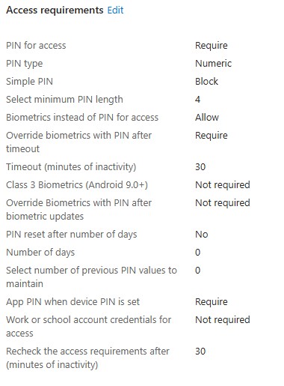
BYOD Android devices will be required to use App Protection Policies, which have been configured to target Microsoft Core Apps. These policies enforce strong access controls by requiring a minimum 4-digit PIN, password, or biometric authentication (such as fingerprint or facial recognition) before accessing corporate applications. Corporate data stored within these apps is encrypted, and the policies restrict cut, copy, and paste between managed Microsoft 365 apps and unmanaged apps, preventing data leakage. In the event a device is lost or stolen, selective wipe will ensure only corporate data is removed without impacting personal information. Jailbroken or rooted devices are not permitted, further reducing security risks.
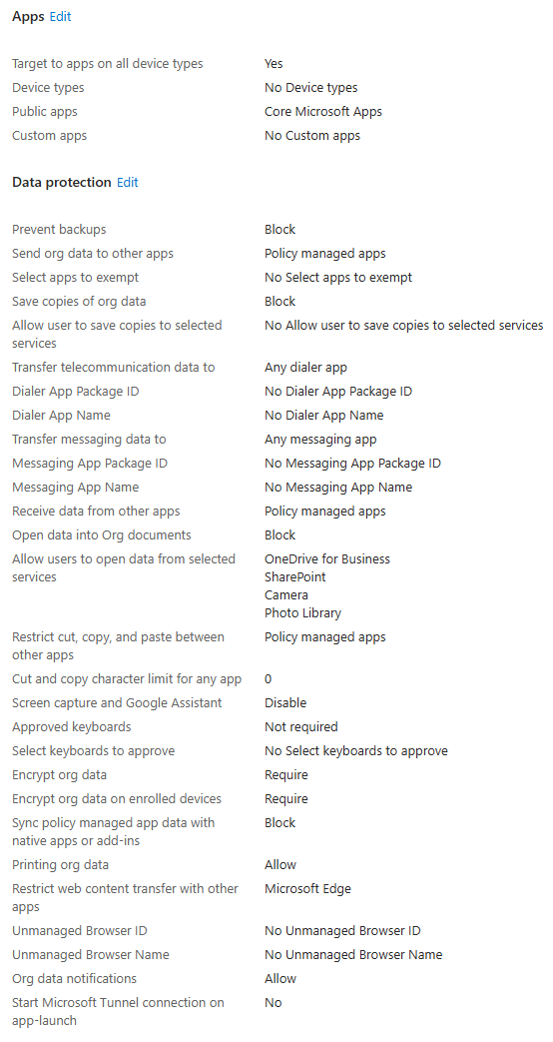
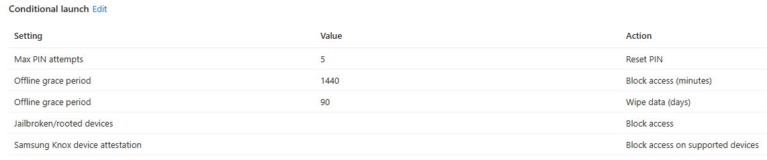
    - iOS
BYOD iOS devices will be required to use App Protection Policies, which have been configured to target Microsoft Core Apps. These policies enforce strong access controls by requiring a minimum 4-digit PIN, password, or biometric authentication (such as fingerprint or facial recognition) before accessing corporate applications. Corporate data stored within these apps is encrypted, and the policies restrict cut, copy, and paste between managed Microsoft 365 apps and unmanaged apps, preventing data leakage. In the event a device is lost or stolen, selective wipe will ensure only corporate data is removed without impacting personal information. Jailbroken or rooted devices are not permitted, further reducing security risks.
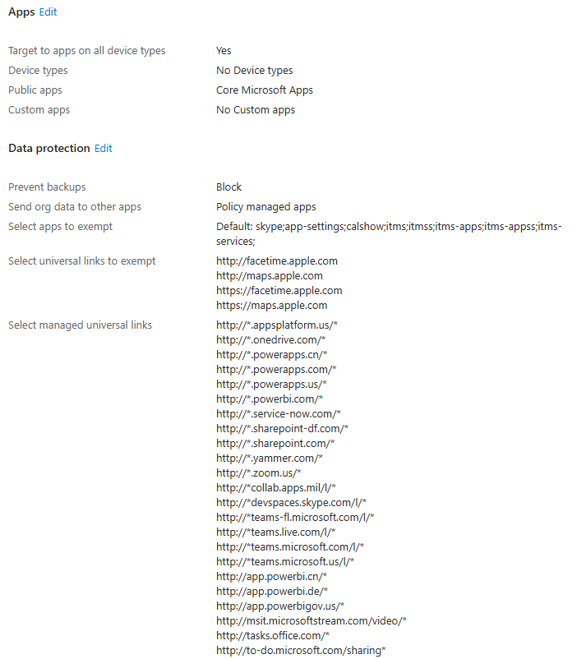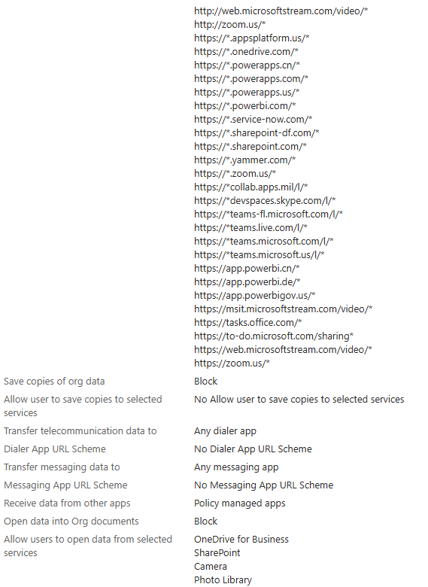
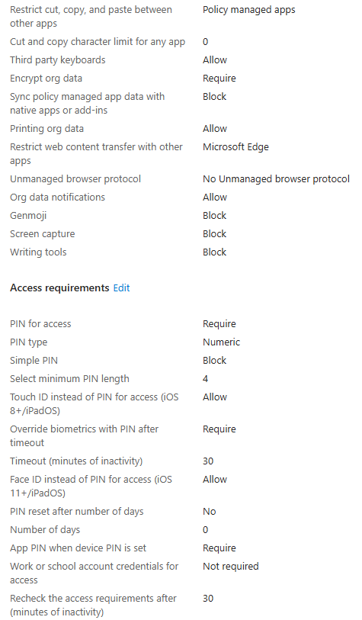
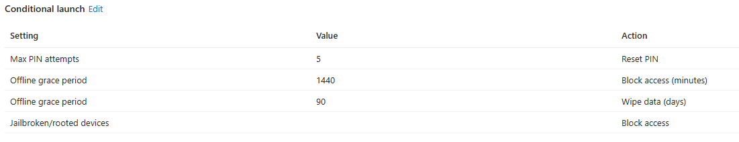
    - Windows
BYOD Windows devices will be required use App protection policies. These have been configured to target Microsoft Edge browser. App Protection policies will prevent downloading, sending data outside off the browser and cut/copy/paste data in or out of the browser. Printing is allowed These policies will only apply to Microsoft Office applications within the browser. Outside of these applications the browser will work normally. This is controlled with Conditional Access Policy. Users do need to register their devices to Entra ID but they won’t be enrolled to Intune. NOTE: this policy is not in use
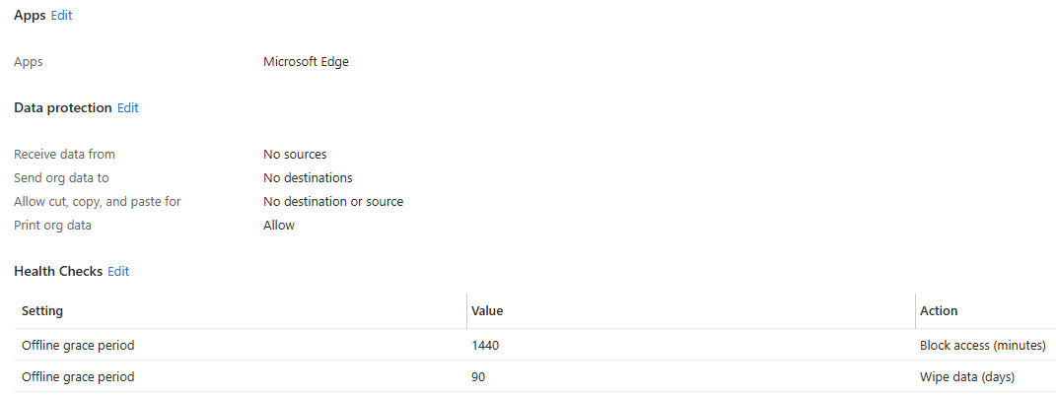
  - Intune MDM Policies
Devices need to be enrolled before they are handed over to the end users. IOS Devices will be enrolled to Intune with Apple Business Manager and Android devices directly with QR code as corporate-owned, fully managed user devices.
    - Orro – iOS Enrollment profile
Orro - iOS Without User Affinity Profile
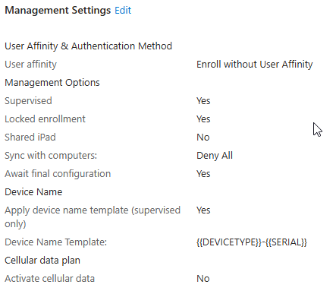
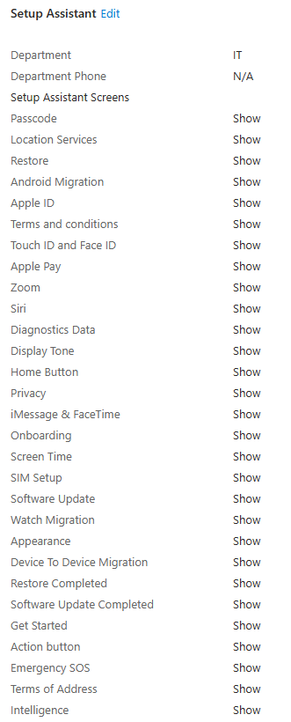
Orro - iOS User Affinity Profile
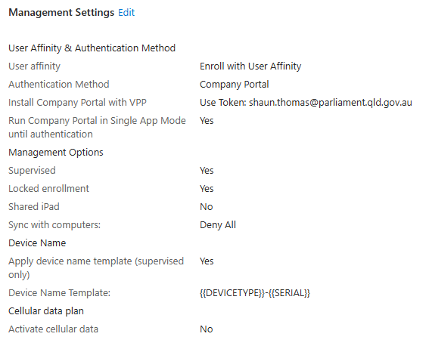
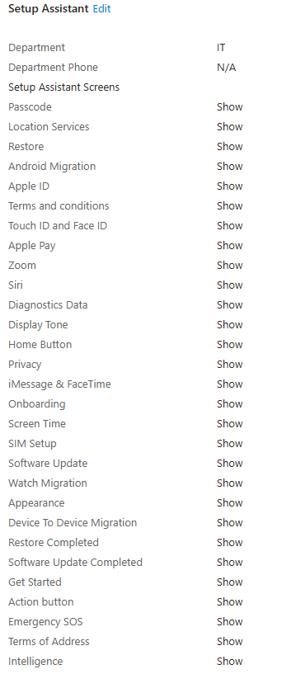
    - Orro – iOS Compliance policy
Orro - iOS compliance policy
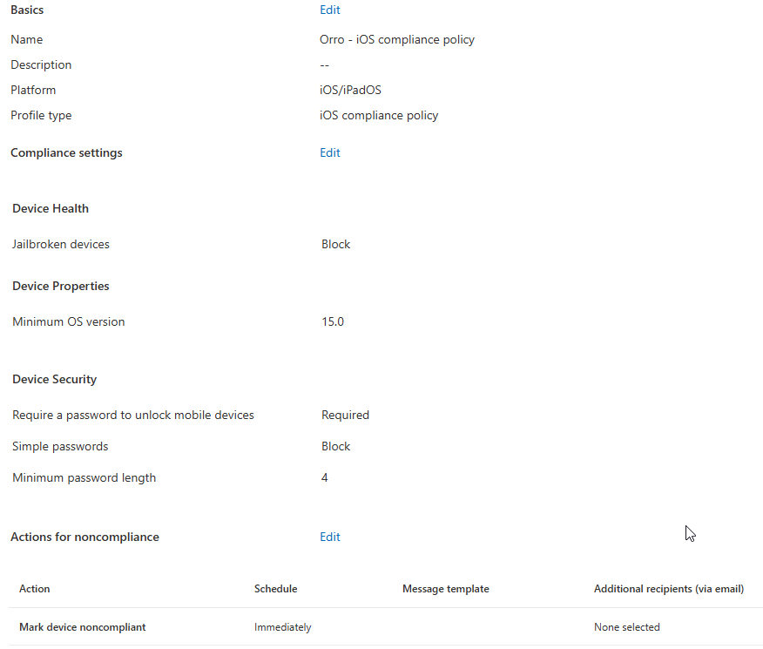
    - Orro – iOS Configuration policies
Orro - iOS Supervised Enhanced Security Configuration
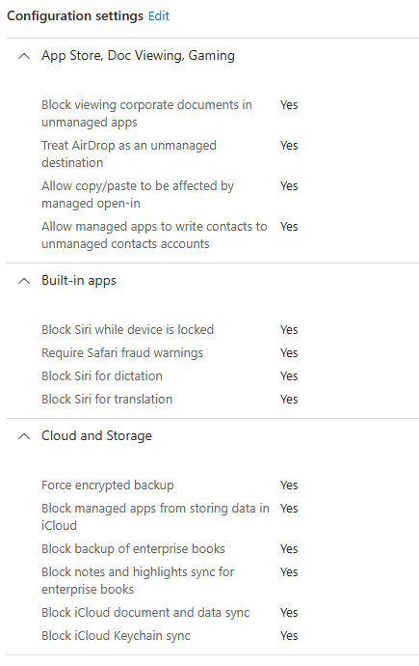
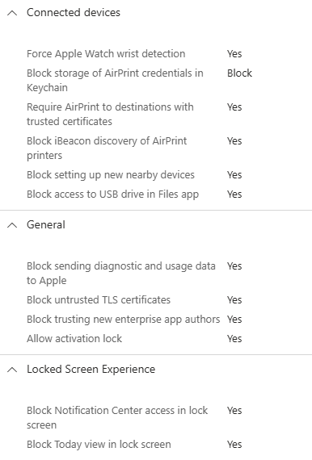
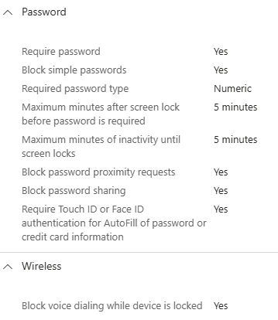
    - iOS Apps
TBA
    - Orro – Android Enrollment profile
Orro - Android - Corporate Owned Fully Managed Enrollment Profile
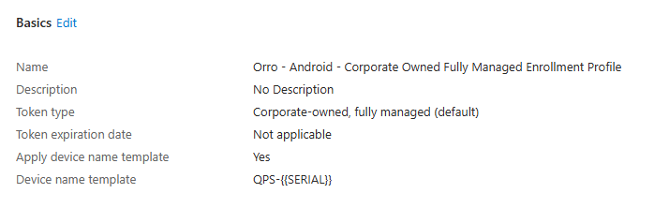
    - Orro – Android Compliance policy
Orro - Android Fully managed enhanced security compliance
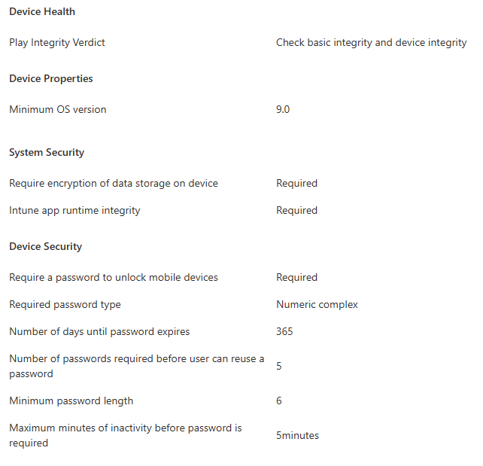
    - Orro – Android Configuration policies
Orro - Android Fully Managed Enhanced Security Configuration
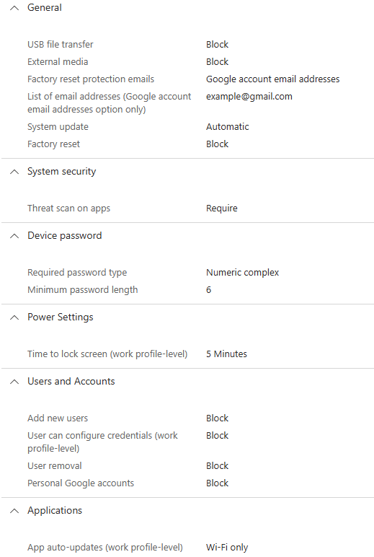
    - Android Apps
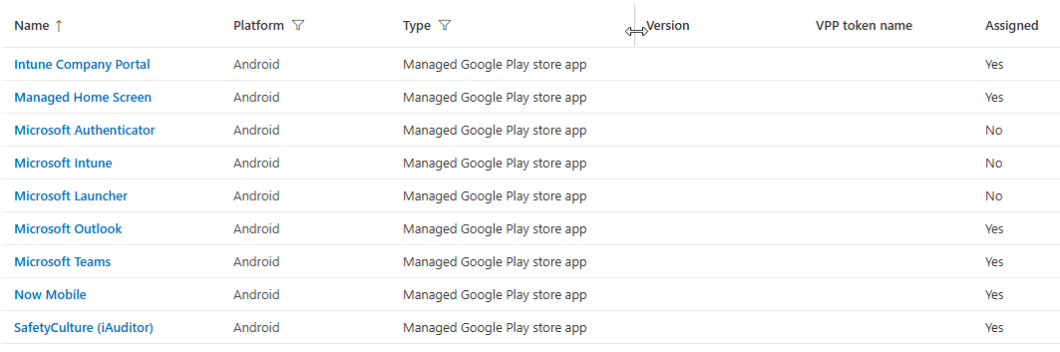
    - Assignment Filters
Orro - QPS - Android Corporate Owned Devices
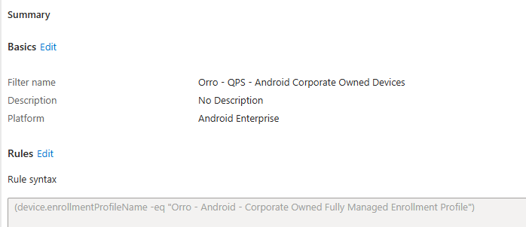
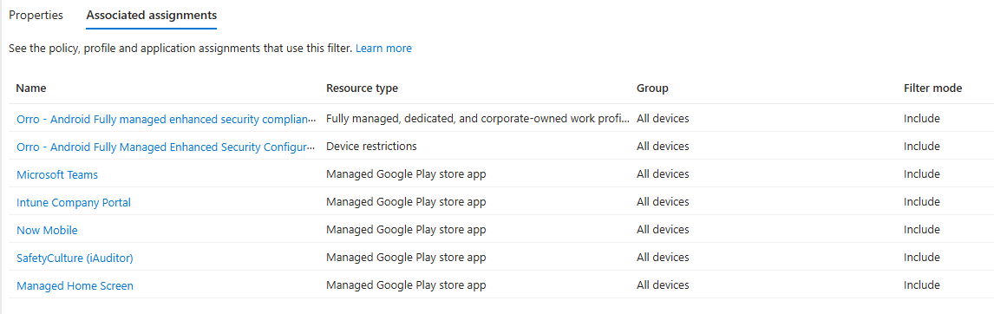
  - Conditional Access Policies
    - Orro – BYOD Allow Web Access
Target Resources
Office 365
Conditions
Device platforms – Included: Windows, macOS
Client Apps – Browser
Filter for devices – Exclude filtered devices from policy: trustType Equals Microsoft Entra Joined or Microsoft Entra Hybrid Joined
Grant
Grant access – Require app protection policy
    - Orro – BYOD Block Desktop Clients
Target Resources
Office 365
Conditions
Device platforms – Included: Windows, macOS
Client Apps – Mobile apps and desktop clients
Filter for devices – Exclude filtered devices from policy: isCompliant Equals True
Grant
Block access
    - Orro – MAM Policy enforce iOS and Android
Target Resources
Office 365
Conditions
Device platforms – Included: Android, iOS
Client Apps – Browser, Mobile apps and desktop clients
Filter for devices – Exclude filtered devices from policy: deviceOwnership Equals Company
Grant
Grant access – Require app protection policy
    - Orro – BYOD macOS/Windows Block download/copy/cut/paste – Office 365 browser (MCAS)
Target Resources
Office 365
Conditions
Device platforms – Included: macOS, Windows
Client Apps – Browser
Filter for devices – Exclude filtered devices from policy: deviceOwnership Equals Company or trustType Equals Microsoft Entra Joined or Microsoft Entra Hybrid Joined
Session
Use conditional Access App Control – Use Custom Policy

  - Microsoft Defender Cloud App Policies
Block download based on real-time content inspection and Block print/cut/copy and paste based on real-time content inspection policy templates will be used to monitor Microsoft Online services in the browser. These policies are applied to Windows and macOS BYOD devices via conditional access
Applications that are controlled with the policy:
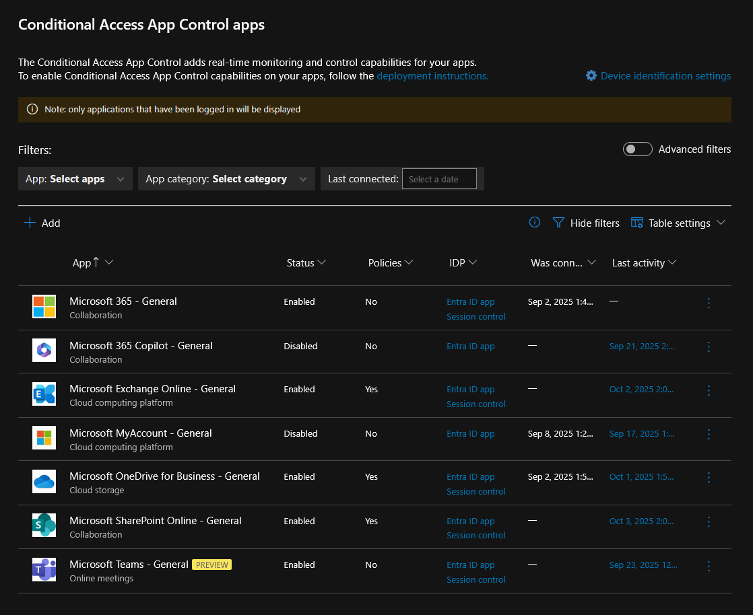
Block cut/copy and paste based on real-time content policy settings:
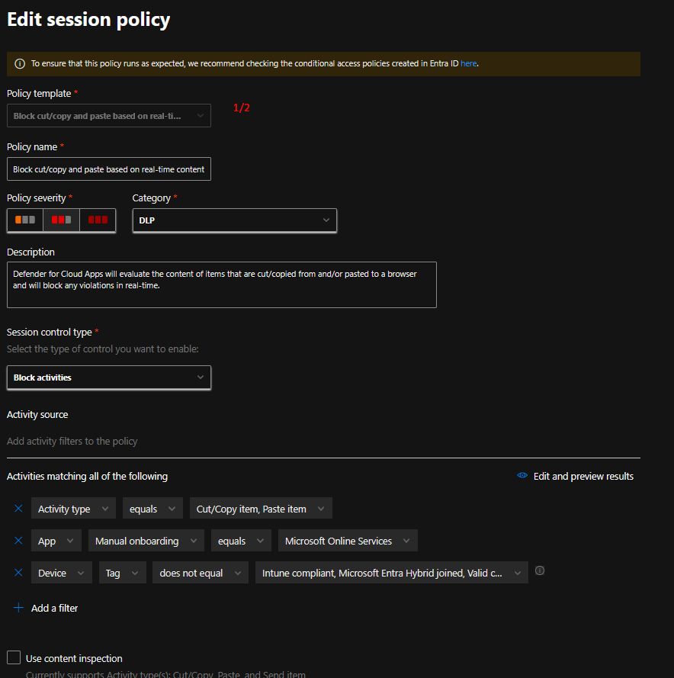
Block download based on real-time content inspection policy settings:
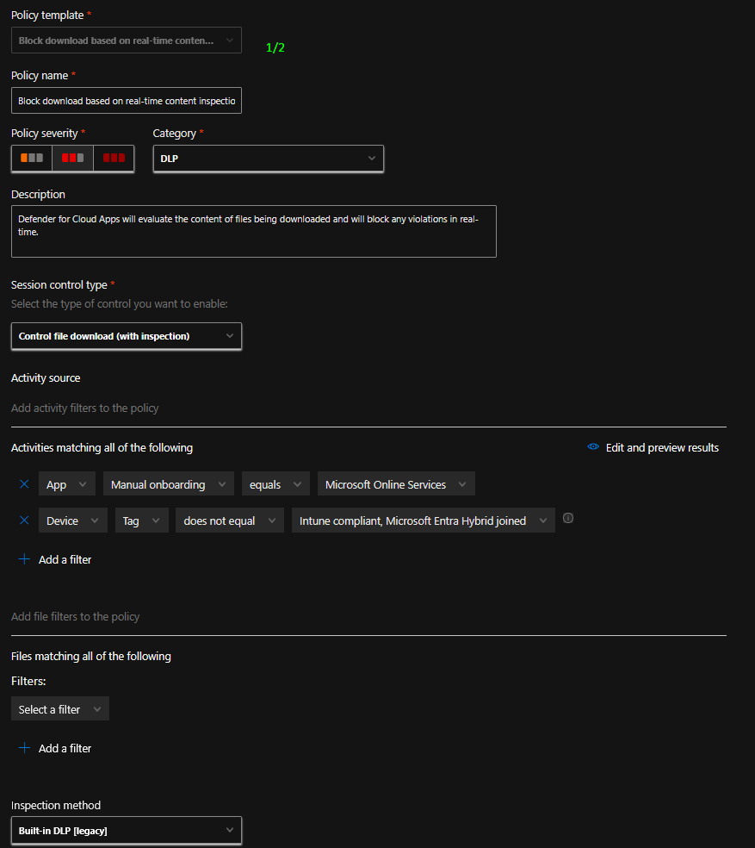
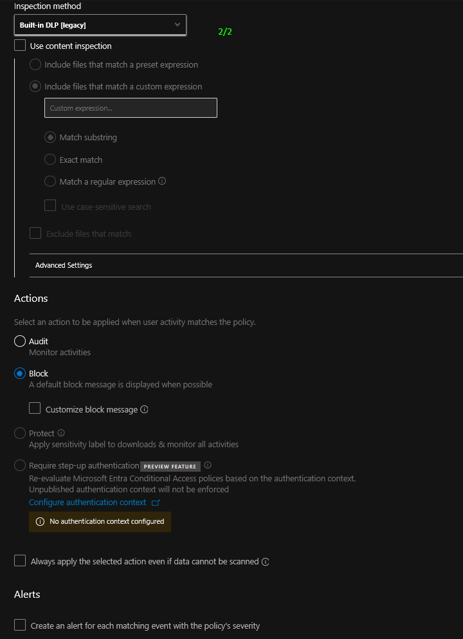


1300 900 000
hello@orro.group
orro.group

